# Setting up Application Environment Create IBM Cloud Account

**Step 1.** Navigate to ibm.com/academic and register with your smartinternz mail

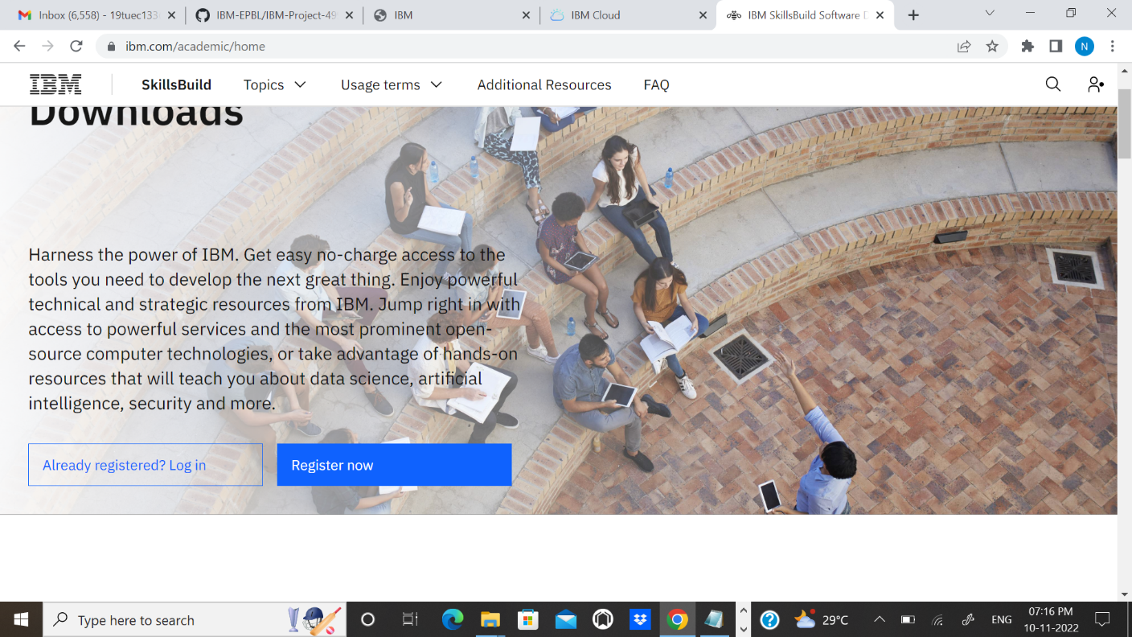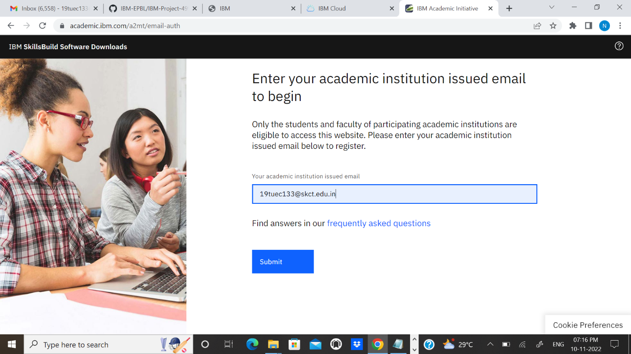

**Step 2**: Now goto cloud.ibm.com and login with your registered mail id along with coupon code obtained fromibm.com/academic

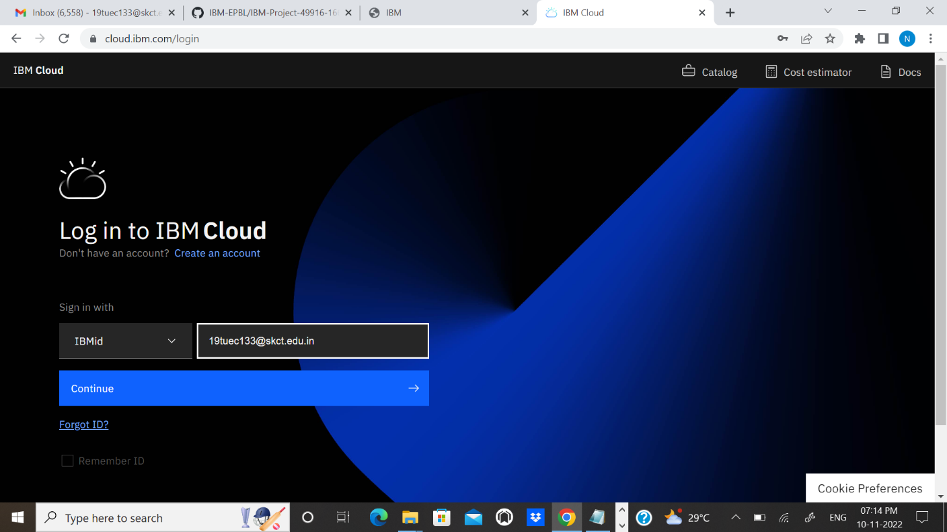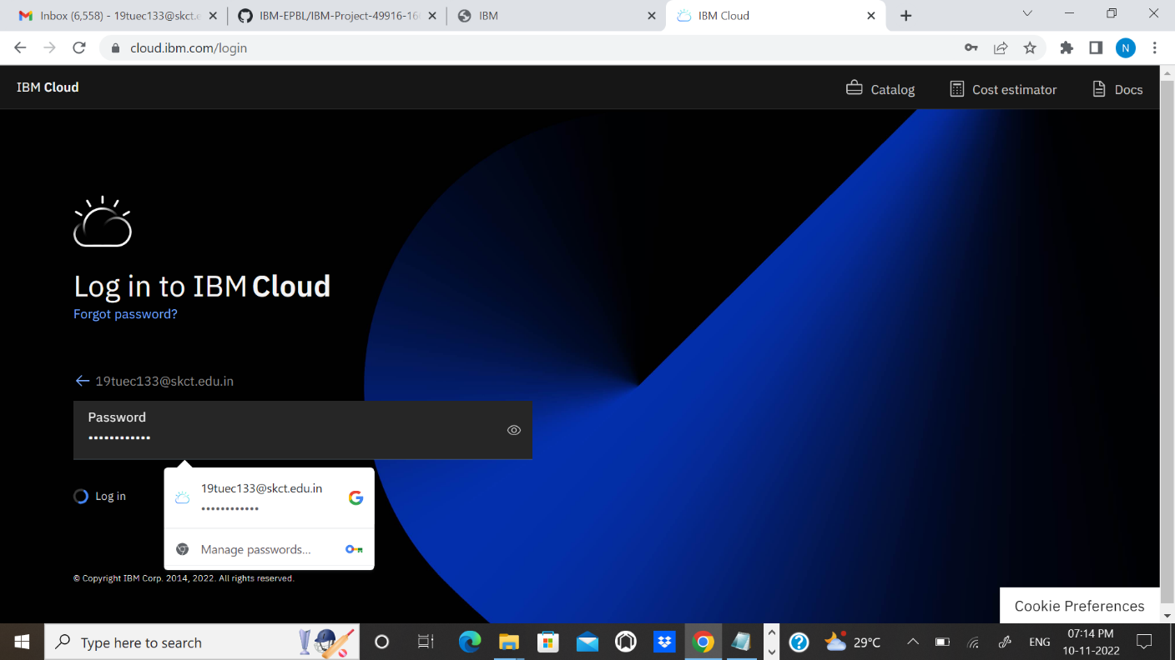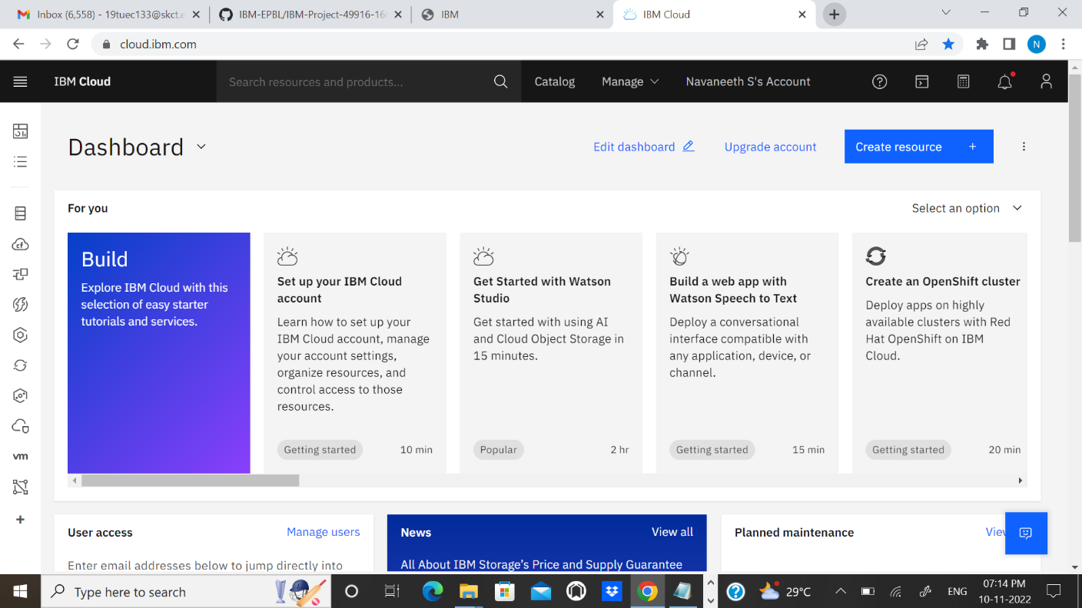

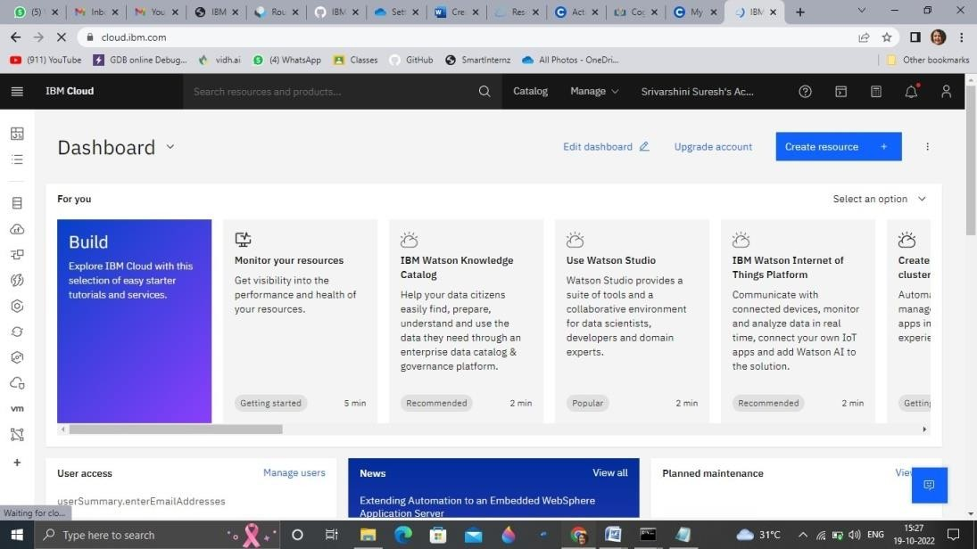

# Output :

Cloud account created successfully.